The Taylor Rule: A benchmark for monetary policy?

The Taylor rule is a simple equation—essentially, a rule of thumb—that is intended to describe the interest rate decisions of the Federal Reserve’s Federal Open Market Committee (FOMC).

r = p + 0.5y + 0.5(p – 2) + 2

(the “Taylor rule”)

Where:

r = the federal funds rate

p = the rate of inflation

y = the percent deviation of real GDP from a target

Normally, the Fed’s “target” for real GDP is potential output, the amount the economy can sustainably produce when capital and labor are fully employed. With that assumption, the variable *y* in the Taylor rule can be interpreted as the excess of actual GDP over potential output, also known as the output gap.

## TAYLOR’S CRITIQUE OF FED POLICY

Originally, John did not seem to believe that his eponymous rule should be more than a general guideline. Indeed, in his 1993 article, he took pains to point out that a simple mechanical rule could not take into account the many factors that policymakers must consider in practice. I believe that John’s original view was sensible. As an economist researcher I often referred to various policy rules, including variants of the Taylor rule. However, it seemed to me self-evident that such rules could not incorporate all the relevant considerations for making policy in a complex, dynamic economy.

* First, John argues that the FOMC kept interest rates much lower than prescribed by the Taylor rule during 2003-2005, and that this deviation was a major source of the housing bubble and other financial excesses.
* Second, he asserts that the Fed’s monetary policy since the financial crisis has not been sufficiently rule-like, and that policy has been too easy. He says that, if the FOMC had been following the Taylor rule, it would have ended its policy of near-zero interest rates several years ago. He blames much of the disappointing recovery on the Fed’s putative deviations from the Taylor rule.

The basis of John’s claims is findings like those of Figure 1 below, which is my update of the original Taylor rule for the period 1993 to the present. To construct Figure 1, I followed Taylor’s original paper and measured inflation using the GDP deflator (more on this in a moment). To measure the output gap, for the period through 2009 I used estimates prepared by Federal Reserve staff for FOMC meetings, which are disclosed after a five-year lag. For 2010 through the present, for which Fed staff estimates of the output gap are not yet publicly available, I used estimates produced and published by the Congressional Budget Office. Importantly, for all figures in this post, I used only data that were known to policymakers at the time they made their decisions. Because initial data are often substantially revised, using real-time data is essential for evaluating policy choices.

[[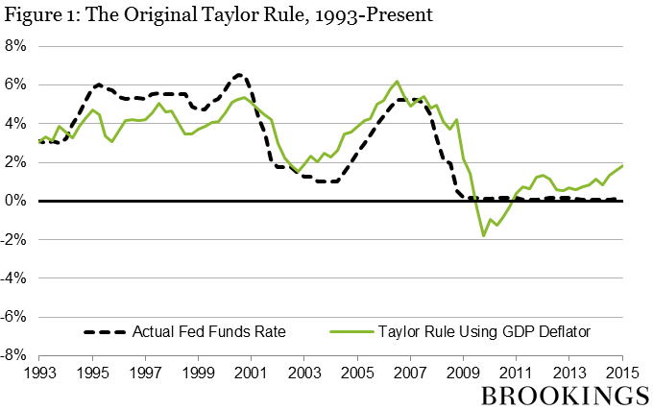](https://www.brookings.edu/wp-content/uploads/2015/04/Taylor_fig1_new.png)](https://www.brookings.edu/wp-content/uploads/2015/04/Taylor_fig1_new.png)

I responded to assertions similar to John’s first claim, that too-easy money caused the US housing bubble, in [a 2010 speech](http://www.federalreserve.gov/newsevents/speech/bernanke20100103a.htm). Briefly, I argued there that the Fed’s interest-rate policies in 2003-2005 can’t explain the size, timing, or global nature of the housing bubble. I won’t repeat those points here.

As for the period since the financial crisis, the modified Taylor rule in Figure 2 suggests that the “right” funds rate was quite negative, at least until very recently. If the Taylor rule predicts a sharply negative funds rate, which of course is not feasible, then it seems sensible for the FOMC to have done what it did: keep the funds rate close to zero (about as low as it can go) while looking for other tools (like purchases of securities) to achieve further monetary ease.2

As John points out, the US recovery has been disappointing. But attributing that to Fed policy is a stretch. The financial crisis of 2007-2009 was the worst at least since the Depression, and it left deep scars on the economy. The recovery faced other headwinds, such as tight fiscal policy from 2010 on and the resurgence of financial problems in Europe. Compared to other industrial countries, the US has enjoyed a relatively strong recovery from the Great Recession.

It’s also true if overall PCE inflation is used as the inflation measure.) If easy money is an important cause of bubbles, how can the large gains in the stock market in the 1990s be reconciled with monetary policy that appears if anything too tight?

* The Taylor rule also assumes that the equilibrium federal funds rate (the rate when inflation is at target and the output gap is zero) is fixed, at 2 percent in real terms (or about 4 percent in nominal terms). In principle, if that equilibrium rate were to change, then Taylor rule projections would have to be adjusted. As noted in footnote 2, both FOMC participants and the markets apparently see the equilibrium funds rate as lower than standard Taylor rules assume. But again, there is plenty of disagreement, and forcing the FOMC to agree on one value would risk closing off important debates.
* The Taylor rule provides no guidance about what to do when the predicted rate is negative, as has been the case for almost the entire period since the crisis.

In our view, those who now counsel policy patience seriously underestimates both the risks that inflation will remain high and the costs of the Fed losing credibility. It is not sufficient to point to low bond yields as evidence that inflation expectations are under control. As [Sargent and Silber](https://www.wsj.com/articles/the-market-is-too-serene-about-inflation-interest-rate-paul-volcker-fomc-federal-reserve-price-stability-11641933266) argue, the bond market was an unreliable indicator during the Volcker disinflation of the early 1980s and it may be lagging again. The continued mix of expansionary fiscal and monetary policies in 2021 (long after the recovery had gained momentum), combined with the Fed’s remarkably unbalanced approach to its dual objectives, provides strong evidence of a shift in the inflation regime. Moreover, high inflation readings are influencing price- and wage-setting on a scale that we have not witnessed in decades.

The way to avoid a costly loss of credibility is to act quickly and decisively. Yet, policymakers likely will have a very difficult time catching up. To see why, we can look at some data on inflation and financial conditions. In the following chart we plot the six-month annualized change in the core consumer price index (CPI excluding food and energy) and the Federal Reserve Bank of Chicago’s national financial conditions index (FCI). Over the past six months, we can clearly see the outsized pickup of inflation (in red on the left-hand scale). Prices are rising at a rate last seen in the early 1980s during the recession associated with the Volcker Fed’s efforts to bring inflation down from double-digit levels. (Replacing the core CPI with the trimmed mean CPI does not alter this pattern.)

Of course, inflation is notoriously difficult to forecast. However, forecast accuracy should encourage greater reliance by policymakers on trend measures of inflation. Put differently, any claim that a positive inflation surprise is transitory embeds the belief that inflation will recede on its own. In recent experience, trend inflation initially rose in April 2021. By June, nearly all measures of core inflation exceeded the Fed’s stated longer-term goal. Combined with the fiscal stimulus and a plummeting unemployment rate, it would have been prudent to begin withdrawing monetary stimulus rather than to rely heavily on inflation-forecasting skills.

Putting this all together, the FOMC needs a plan to raise rates quickly and substantially. By how much? To get a sense of the magnitudes, we compute a simple Taylor rule and display the results in the next chart. Starting with the history, we show the actual federal funds rate target in black and the Taylor rule rate in solid red. The two follow each other relatively closely from the mid-1980s through 2007. Importantly, however, during periods when the policy rate falls persistently short of the Taylor rule rate, as in the 1970s, inflation tends to rise.

Federal Funds Rate, Taylor Rule rate, and projected rule rates, quarterly, 1970-2024

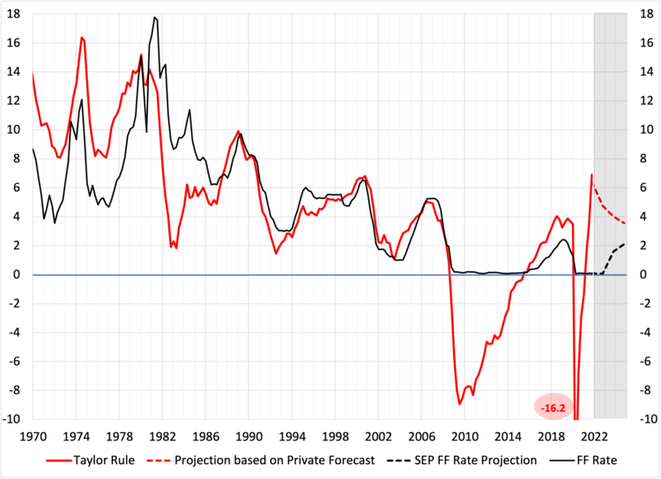

Turning to the more recent period, we see that by the end of 2021, with ex-food and energy PCE inflation running about 4½ percent, the Taylor rule implied a policy rate of nearly 7 percent. Even if core inflation comes down by a percentage point during 2022—that is, by more than the recent trimmed mean PCE inflation rate implies—the projected Taylor rule rate will remain above 5 percent. While it is not obvious from the chart, for the FOMC to ensure inflation returns to its target of 2%, policymakers likely will need to bring the short-term *real* interest rate into significantly positive territory. Put slightly differently, we suspect that the policy rate needs to rise to at least one percent above expected inflation.

Applying the painful lesson of the 1970s and early 1980s leads us to conclude that the FOMC now needs to show clear resolve. Inflation rose very quickly, so it may still be possible to bring it down sharply without a recession. The more decisively policymakers act, the lower the long-run costs are likely to be. Indeed, we are skeptical of arguments that an aggressive Fed tightening would be particularly damaging over time to those with lower incomes. Rather, the experience of recent decades is that job and wage gains for those with low incomes are most closely associated with long, relatively steady expansions. Failure to restore price stability in a timely way would almost surely render this expansion disturbingly short compared to recent norms.

[*Permalink*](https://www.moneyandbanking.com/commentary/2022/2/12/fed-monetary-policy-in-crisis)

*Tags:*[*Federal Reserve*](https://www.moneyandbanking.com/commentary/tag/Federal+Reserve#show-archive)*,*[*Monetary policy*](https://www.moneyandbanking.com/commentary/tag/Monetary+policy#show-archive)*,*[*Inflation*](https://www.moneyandbanking.com/commentary/tag/Inflation#show-archive)*,*[*Price stability*](https://www.moneyandbanking.com/commentary/tag/Price+stability#show-archive)*,*[*Trend inflation*](https://www.moneyandbanking.com/commentary/tag/Trend+inflation#show-archive)*,*[*Inflation forecast*](https://www.moneyandbanking.com/commentary/tag/Inflation+forecast#show-archive)*,*[*Credibility*](https://www.moneyandbanking.com/commentary/tag/Credibility#show-archive)*,*[*Policy strategy*](https://www.moneyandbanking.com/commentary/tag/Policy+strategy#show-archive)*,*[*Average inflation targeting*](https://www.moneyandbanking.com/commentary/tag/Average+inflation+targeting#show-archive)*,*[*Taylor rule*](https://www.moneyandbanking.com/commentary/tag/Taylor+rule#show-archive)*,*[*Inflationary bias*](https://www.moneyandbanking.com/commentary/tag/Inflationary+bias#show-archive)*,*[*Zero lower bound*](https://www.moneyandbanking.com/commentary/tag/Zero+lower+bound#show-archive)*,*[*ZLB*](https://www.moneyandbanking.com/commentary/tag/ZLB#show-archive)*,*[*Paul Volcker*](https://www.moneyandbanking.com/commentary/tag/Paul+Volcker#show-archive)*,*[*Inflation persistence*](https://www.moneyandbanking.com/commentary/tag/Inflation+persistence#show-archive)*,*[*FAIT*](https://www.moneyandbanking.com/commentary/tag/FAIT#show-archive)*,*[*Summary of Economic Projections*](https://www.moneyandbanking.com/commentary/tag/Summary+of+Economic+Projections#show-archive)*,*[*SEP*](https://www.moneyandbanking.com/commentary/tag/SEP#show-archive)*,*[*Financial conditions*](https://www.moneyandbanking.com/commentary/tag/Financial+conditions#show-archive)*,*[*Recession*](https://www.moneyandbanking.com/commentary/tag/Recession#show-archive)

While the headline inflation rate has been volatile due to shifts in energy prices, the core inflation and GDP deflator have moved closer together, with the GDP measure being more stable than core inflation, since even core inflation contains some raw material prices[[2]](https://www.ceps.eu/ceps-publications/time-ecb-normalise-its-monetary-policy-insights-taylor-rule/" \l "_ftn2" \o ") (see Figure 1).

With these assumptions, we find that for the ECB the Taylor rule would have prescribed a higher interest rate prior to the crisis and thereafter a much faster and deeper decline (see Figure 2). According to the Taylor rule, based on ex post data, 2015 would have been the point in time when the ECB should have started to raise the interest rate. In reality, this is when the ECB did the opposite by loosening further monetary conditions through its massive bond purchase programme.

CEPII (2016) translates the impact of the bond purchases into an equivalent measure of policy easing, by estimating the so-called shadow interest rate; namely the policy rate without a zero bound that the ECB would have had to adopt to achieve the same monetary conditions as it did with the quantitative easing (QE) effects. They find that the shadow rate would have dropped below -3%. The ECB has thus followed the opposite direction of the trend suggested by the Taylor rule.

For 2016, both ex ante and real-time data[[3]](https://www.ceps.eu/ceps-publications/time-ecb-normalise-its-monetary-policy-insights-taylor-rule/" \l "_ftn3" \o ") would have called for an increase of its interest rate. Using the output gap and the GDP deflator as provided by the European Commission forecasts for 2017, the rule’s predicted policy rate points to a further increase led by another narrowing of the output gap[[4]](https://www.ceps.eu/ceps-publications/time-ecb-normalise-its-monetary-policy-insights-taylor-rule/" \l "_ftn4" \o ") and a rise in the deflator.

Figure 2. The Taylor rule for the eurozone

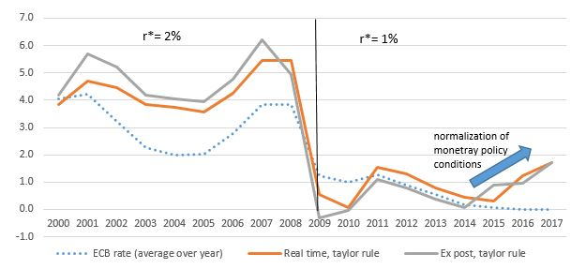

The time has come to prepare for an exit from unconventional policies that are no longer needed, given the absence of any signs of deflation.